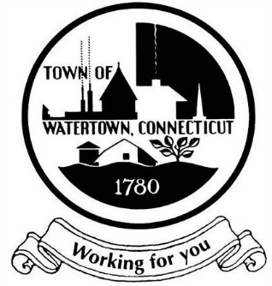
TOWN OF WATERTOWN
PLANNING AND ZONING COMMISSION
REGULAR MEETING AGENDA
Wednesday, May 6, 2026, 6:30 p.m.
Watertown Town Hall, Town Council Chambers
61 Echo Lake Road

- CALL TO ORDER – Welcome to the meeting
- PLEDGE OF ALLEGIANCE
- ROLL CALL
- PUBLIC PARTICIPATION
- APPROVAL OF MINUTES
  - Regular Meeting – April 1, 2026
- STAFF REPORT
- CHAIRMAN’S REPORT
- OLD BUSINESS

  - 28 Riverside Street – Solli Engineering on behalf of Palm Coast Capital, LLC (Tractor Supply) – Site plan modification to approved site plan #2025-05 to increase driveway grade, elevation of proposed development, and replace stormwater detention basin with an underground detention system.

  - 110 Woodbury Road – Stephanie Cummings, Esq. (Carmody) on behalf of the Taft School – Petition for waiver of fees pursuant to Ordinance 36-4 Taft School, 110 Woodbury Road, Watertown, CT. (Petition received March 4, 2026).

- CONTINUED PUBLIC HEARINGS

  - 110 Woodbury Road – Stephanie Cummings, Esq. (Carmody) on behalf of the Taft School – Site Plan / Special Permit for the construction of two new 45,000 ft² dormitories with associated site improvements to include landscaping, walkways, and stormwater management. (Application received March 4, 2026, Public Hearing April 1, 2026).

- NEW BUSINESS

  - 758 Litchfield Road – Elvis Methoxha – 8-24 review for the sale of a town-owned parcel (MBL# 053-33A-009) for the construction of a new driveway with improved sightlines.

  - 470 Straits Turnpike – Carmine Castiglione – Permit extension request for a site plan / special permit approval for an age-restricted housing development to expire on 12/1/26. Approval initially granted on 12/1/21.

  - 178-184 Commercial Street – Bela Sztanko – Zone change request from IR-80 B-SC to allow for car sales and repairs. Application received 5/6/26.

- PLANNING

  - Discussion of potential text amendment to allow bulk material storage in the IR-80 zoning district or the rezoning of parcels along Echo Lake Road from the IR-80 IG-80 zoning district between Park Road and Rte. 8.

- COMMUNICATIONS AND BILLS

  - UCONN Extension Expanding Connecticut Agriculture through vacant lot activation and peri urban Farmland Access linking.

  - City of Waterbury Zoning Commission Notice of Proposed Zoning Amendment, Public Hearing June 24, 2026 for the purpose of permitting Religious Institutions by Special Permit in the Park Industrial District.

- ADJOURNMENT

- Next Meeting Date: June 3, 2026

Respectfully submitted,

Raymond Antonacci, Chairman
Planning and Zoning Commission
Town of Watertown, CT 5/1/26

THIS MEETING WILL BE AN IN-PERSON MEETING AND WILL ALSO BE AVAILABLE VIA ZOOM FOR LISTEN ONLY. A LINK WILL BE POSTED ON THE DAY OF THE MEETING. PLEASE SEE WWW.WATERTOWNCT.ORG - UNDER THE CALENDAR OF MEETINGS

